
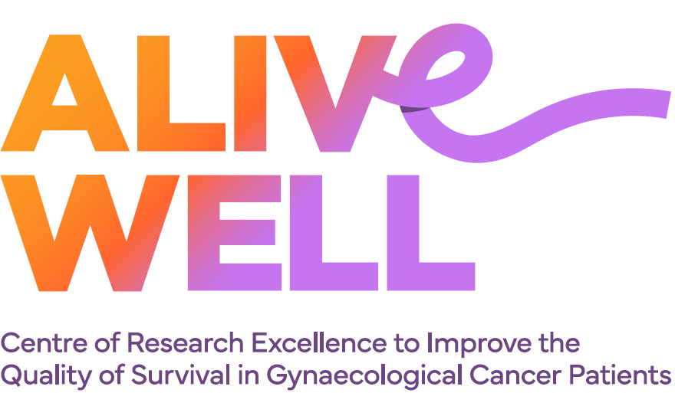

ALIVE WELL Cherish Women’s Cancer Foundation Grants Program

Seed Funding Grant Application Form

Please see the Grant Guidelines for further information.
If you experience any difficulty completing this form, please contact the ALIVE WELL Program Manager at ALIVEWELL.centre@uq.edu.au or 07 3346 5031.

Applicant Information
Name: | Enter your full name
Research group and Institution  (if applicable): | Enter your research group and institution
Role in ALIVE WELL: | ☐ ALIVE WELL trainee (e.g. MPhil or PhD candidate, clinician research fellow, early-career researcher, or mid-career researcher)  ☐ Consumer research partner
Email address: | Enter your email address
Phone number: | Enter your phone number

Project Information
Project Title: | Enter your project title
Project start date: | Select the project start date
Project end date: | Select the project end date
Have you applied or intend to apply for funding for this research elsewhere? | ☐ Yes  ☐ No  If yes, please provide details of the funding source(s), amount requested, and application status.  Enter details of the funding source(s), amount requested, and whether the application has been submitted, approved, declined, or is pending.
Have you previously been a recipient of an ALIVE WELL Cherish Women’s Cancer Foundation Grant? | ☐ Yes  ☐ No  If yes, please provide the end date of your previous grant: Select a date

Research Project

Brief description of the proposed project (maximum 100 words)

Provide a brief overview of the proposed research project and its intended outcomes.

Background (maximum 200 words)

Describe the problem being addressed, current evidence or gaps in knowledge, and the rationale for undertaking the proposed project.

Aim (maximum 200 words)

State the overall aim of the project.

Primary objective(s) (maximum 200 words)

Describe the main objective(s) of the project.

Secondary objective(s) (maximum 200 words)

Describe any secondary objective(s), if applicable.

Research Plan (maximum 2 pages)

Describe how the project will be undertaken, including the methodology, key activities, timeline, and anticipated outputs.

Consumer Involvement (maximum 200 words)

Where consumers are involved, describe their involvement in the development and conduct of the research project. If consumers are not involved, briefly explain why not.

Ethics requirements

Will this project require ethics approval or other regulatory approvals?

Yes ☐ No ☐

If yes, please provide details.

Describe the approvals required and, if known, the status of any applications.

A copy of the final ethics approval (or formal exemption letter, where applicable) must be provided to the ALIVE WELL Program Manager before funding can be released.

Project Team & Host Institution

List all members of the project team and their role in the proposed research project (add additional rows as required).

For applications submitted by a consumer research partner, at least one ALIVE WELL Chief Investigator or trainee should be included in the project team to support the development and delivery of the proposed research project.

Note: The assessment panel may request additional information regarding project team expertise, where required.
Name | Position / Organisation | Email address | Role on project | Hours/week on project
Host Institution

The proposed research project must be supported by a host institution that agrees to facilitate the conduct of the project and administer any awarded funds.
Enter the host institution.

Alignment with ALIVE WELL Objectives and Priority Areas
CRE Objectives
Select all that apply:
☐ Generate new knowledge
☐ Promote effective transfer of research outcomes into policy and practice
☐ Develop the health and medical research workforce
☐ Facilitate collaboration
Priority Areas
Select all that apply:
☐ Enabling fertility after endometrial cancer
☐ Reducing lymphoedema incidence
☐ Enhancing cancer recovery
Briefly describe how the proposed research project aligns with the selected objective(s) and priority area(s) (maximum 200 words).
Describe how the proposed research project aligns with the selected objective(s) and priority area(s).

Alignment with the Cherish Women’s Cancer Foundation Mission
Cherish Women’s Cancer Foundation Mission:
To give every woman hope and a vibrant chance for surviving gynaecological cancer by funding research into clinically prioritised trials for treatments, diagnosis and prevention.
Briefly describe how the proposed research project aligns with the Cherish Women’s Cancer Foundation mission (maximum 200 words).
Describe how the proposed research project supports the Cherish Women’s Cancer Foundation mission.

Budget (excluding GST)
Provide a breakdown of the funding requested (add additional rows as required). Budget items must align with the eligible expenses outlined in the Grant Guidelines.
Total funding requested must not exceed $10,000.
Budget item | Justification | Cost ($)
Total funding requested |  | $

Certifications
Certification by Applicant
I certify that the information provided in this application is true and complete.
I certify that all parties identified in this application have agreed to their involvement and to the submission of this application.
I understand and agree that, before the proposed research can commence, all required ethical and other relevant clearances must be obtained.

Signature: Insert signature Date: Select the date of signing

Certification by Host Institution Representative
This certification should be completed by an appropriate representative of the host institution authorised to support grant applications and administer awarded funds.
I support this application and confirm that the proposed research project can be undertaken with the facilities, resources and support available to the project team.
Where funding is awarded, the host institution agrees to facilitate the conduct of the project and administer the awarded funds.
Name: Enter full name.
Position: Enter position or role.
Organisation: Enter organisation or institution.

Signature: Insert signature. Date: Select the date of signing

Instructions for submission
- Complete all sections of this application form
- Name the documents: YEARMMDD_Surname.pdf
- Email documents to: ALIVEWELL.centre@uq.edu.au

